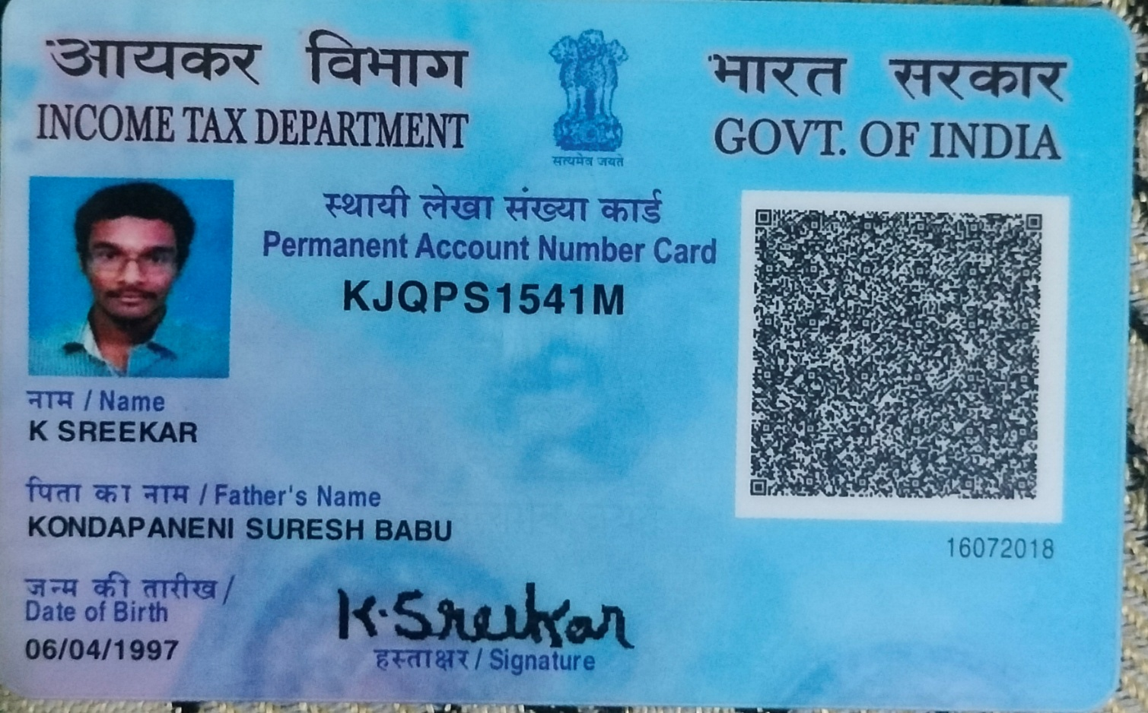

SREEKAR KONDAPANENI

Candidate's Full Legal Name (as it appears on PAN) | SREEKAR KONDAPANENI
Supplier Name (Registered Name) | People-Prime Worldwide
Worked for CG previously? (IF yes share CG Employee ID/GGID required) | No
JOB Posting ID | CGEMJP00343976
Contact No (10 Digit No) | 7299398120
Email ID | ksreekar02@gmail.com
Job Location (Work Location) | Bengaluru
Notice Period (Immediate/ Notice to Serve) | 20/3/2026
Highest Education (Regular or Distance) | B.Tech-2019
Employment Detail – Last 2 yrs Working period (Payroll Company) | Caterpillar Inc
College & University Full Name - | B.Tech / B.E. Anna University, 2019
Mandatory Skills & Experience  (quick checklist – verify each skill, years of experience) | Total-6 Years  Teamcenter - 6 Years  PLM - 6 Years
“Secondary” Skills & Experience | Total-6 Years  Teamcenter - 6 Years  PLM - 6 Years
Key Remarks (Supplier Comment) | Candidate Good at Communication Skill.  he is with 6 years of Total experience and Relevant experience in “Teamcenter and PLM”, is 6 years.

SREEKAR KONDAPANENI
PLM ENGINEER

PROFILE
Phone: 7299398120
E-mail: sreekar06041997@gmail.com

A Experienced PLM engineer with 6+ years in mechanical industry, specializing in Product Lifecycle management (PLM), management of Bill of Materials (BOM) & Engineering Change/release Management using PLM software (Teamcenter and EDS).

EDUCATION
B.E Mechanical Engineering Agni College of Technology affiliated to Anna University. Pass out year 2019, with 7.73 CGPA.
HSC St Savio Matriculation Higher Secondary School. Pass out Year 2015, with 85.1%.
SSLC St Savio Matriculation Higher Secondary School. Pass out Year 2015, with 86.8%.

WORK EXPERIENCE
Caterpillar India (GGS Engineering Service) (February 2023 – March 2026)

ROLES & RESPONSIBILITES
- Constantly collaborating with the product definition engineers (PDE) & Technical lead engineers (TLE) to identify the problems & convert them into engineering change orders (ECO) adhering to the process in Teamcenter Integration and EDS.
- Preparing drawing & BOM markups for the manufacturing and suppliers based on the business needs.
- Expertise in obsolete management of parts and drawings and managing part usage guidelines in the system.
- New BOM creation & Review ECOs for content completeness.
- Creating Engineering Change Notice (ECN) as per the request raised by our respective upstream design engineers
- Implementing the change notice in BOM tools like Teamcenter structure manager and some of the ERP tools.
- Engineering Change Management and Engineering Release Management has been done by creating change notice in Teamcenter and Engineering Data System along with releasing activities.
- Handling AEM work in multi-structure and also single structure with corresponding with sales models and also configuring them against the respective engineering model.
- Having knowledge in creating ADF and FSN workflow.
- Support Cost reduction initiatives - Identify cost-saving and quality improvement opportunities through BOM data analysis.
- Lead BOM review meetings with cross-functional teams for resolution of open issues and participate in engineering change and launch reviews.
- Manage engineering change orders and update BOMs accordingly. Assist in coordinating with R&D, engineering/process changes and minimizing obsolete materials.
- Proficient in part number creation, BOM material management and drawing preparation using Teamcenter, ACTE, along with drawing notice creation and approval.
- Review the change given by the design team and create misc data change
- Cross functionally worked closely with the IT team, product owner and various stakeholders to gather the requirements and communicating with scrum team for our PLM tool development.

  - Vee S Vee Industries (August 2020 – August 2022)

ROLES & RESPONSIBILITES
- Analyzed customer complaints and engaged directly with customers to clarify failure analysis details via corrective and preventive actions.
- Upheld process documentation, procedures, work instructions, etc., in compliance with IATF certification requirements.
- Acquired skills in 5 Core tools and tackled problems efficiently using 8D & 7QC tools
- Undertook quality analysis of all manufacturing processes (new or existing).
- Identified, scrutinized, and executed continual quality improvements in design and manufacturing process efficiency, Safety, Quality, and Cost.
- Authored and updated over 20 Standard Operating Procedures (SOPs) and visual work instructions.
- Possess a thorough understanding of product design and development.
- Conducted quality analysis of manufacturing processes to ensure compliance and consistency.
- Developed and implemented supplier quality management and assurance programs.
- Prepared and executed supplier audit plans, including assessments and reporting.
- Managed supplier qualification, evaluation, and performance review activities.
- Led root cause analysis for supplier-related quality issues and implemented corrective actions.
- Coordinated closely with purchasing and manufacturing teams to resolve quality challenges.
- Collaborated with design teams to simulate and resolve recurring production issues.
- Headed cross-functional teams during audits and new product introduction phases.
  - Impack Fabrications Pvt Ltd (May 2019 – July 2020)

ROLES & RESPONSIBILITES
- Implemented 5 Core Tools and championed continuous quality improvement projects.
- Conducted product and process audits to identify areas for improvement.
- Led calibration and maintenance of gauges and instruments to ensure accuracy.
- Developed strategies to reduce process variability and improve product quality.
- Facilitated internal quality reviews and documented audit findings.
- Coordinated quality initiatives with production and engineering departments.
- Ensured compliance with ISO and internal quality standards.
- Maintained thorough records for inspections, non-conformities, and corrective actions.
- Provided support during external audits and regulatory inspections.

CORE COMPETENCIES
- BOM Management: EBOM to MBOM Translation, Configuration Control, ERP/PLM Systems
- Process Engineering: SOP Development, Work Instructions, Time Studies
- Fabrication & Welding: Weldment Design, Welding Symbols (AWS/ISO), GD&T
- Continuous Improvement: Lean Manufacturing, Six Sigma, Root Cause Analysis (RCA), 5S

SOFTWARE SKILLS
- Having Knowledge in Auto Cad, CREO, ANSYS and CATIA V5 software’s.
- Strong proficiency in PLM and ERP software (EDS, Teamcenter, Upgrade)
- Worked on software like ESMS, PRWB, EA, SOS & Vis mockup.
- Knowledge in Microsoft applications (Microsoft Power point, Microsoft E-Xcel Macros, Microsoft Word).
- Six Sigma Black belt certification.

INTERPERSONAL SKILLS
- Highly Collaborative with strong communication skill.
- Leadership Quality
- Being Organized
- Proactive in solving problems and time management

